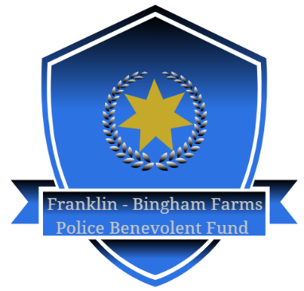

**FRANKLIN - BINGHAM FARMS POLICE BENEVOLENT FUND**

MEETING MINUTES

October 5, 2021

Held at the Franklin-Bingham Farms Police Station, Franklin, Michigan

1. **Meeting Called to Order at 4:35pm, President Daniel Roberts**

A. Welcome and Opening Comments. Present were Roberts, Goldberg, Bastianelli, Jacob, Russell, and Wells (via video conference). Stein was absent due to illness.

B. Approval of Agenda – motion by Jacob, second by Goldberg - motion carried.

C. Approval of Meeting Minutes of 4/6/2021 – motion by Goldberg, second by Jacob – motion carried.

D. Introduction of Board members. President Roberts welcomed all who were in attendance and thanked them for their participation and support

1. **Vice President Fred Goldberg – No Report.**
2. **Secretary Treasurer Report, Secretary Treasurer Michael Bastianelli**
3. Current balance in account is $49,328.91.
4. Expenditures to date during 2021 $4,273.83. Expenditures included legal fees, insurance costs, website development, postage costs and printing expenses.
5. Donations received to date during 2021 were $11,875.00.
6. The Secretary also briefed a heart check program for all Officers that was being provided by a local cardiologist for the Benevolent Fund members.
7. **Communications Plan and Discussion.**

1. The volunteer Social Media Coordinator has been updating the Facebook page regularly and there are links to the GoFundMe and PayPal donation portals.
2. The Secretary demonstrated the new Website that was developed by Blastwave Technologies. The Website has not yet been finalized as there were some modifications ongoing.
3. The Board discussed fund raising during the fall of 2021 and approved the use of Allegra Printing to mail a letter to all residents in Franklin and Bingham Farms.
4. Contact to be made with a marketing firm to assist in advertisement and publishing marketing material to promote the fund.
5. Board Member Russell discussed reaching out to outside communities, business and organizations to solicit donation.
6. **Establishment of Committees Discussion**. No committees required at this time.
7. **Old Business** – The President briefed contact that was made with a company called Real Integrated, which is a large marketing firm. Based on the cost associated with Real Integrated’s proposal, it was decided to not move forward with their marketing plan at that time.
8. **New Business** – The Board discussed other potential fund-raising opportunities, perhaps using Franklin Hills Country Club for either a golf outing or a cocktail party. Discussion was tabled due to on-going Covid concerns. Future discussions of this type of fund-raising can be done once the Pandemic had ended.

**VIII. Adjournment** 5:45pm.